POST:<http://localhost:5000/prediction>: ADD NEW DEVICE AND PREDICTING THE PRICE

GET :<http://localhost:8080/api/devices> : GET ALL DEVICES

GET: [http://localhost:8080/api/devices/{id}](http://localhost:8080/api/devices/%7bid%7d): GET DEVICE BY ID

POST: [http://localhost:8080/api/devices/predict/{id}](http://localhost:8080/api/devices/predict/%7bid%7d) PERDICT PRICING

# From test data :

{

    "battery_power": 1043,

    "blue": **true**,

    "clock_speed": 1.8,

    "dual_sim": **true**,

    "fc": 14,

    "four_g": **false**,

    "int_memory": 5,

    "m_dep": 0.1,

    "mobile_wt": 193,

    "n_cores": 3,

    "pc": 16,

    "px_height": 226,

    "px_width": 1412,

    "ram": 3476,

    "sc_h": 12,

    "sc_w": 7,

    "talk_time": 2,

    "three_g": **false**,

    "touch_screen": **true**,

    "wifi": **false**

}

{

    "battery_power": 841,

    "blue": **true**,

    "clock_speed": 0.5,

    "dual_sim": **true**,

    "fc": 4,

    "four_g": **true**,

    "int_memory": 61,

    "m_dep": 0.8,

    "mobile_wt": 191,

    "n_cores": 5,

    "pc": 12,

    "px_height": 746,

    "px_width": 857,

    "ram": 3895,

    "sc_h": 6,

    "sc_w": 0,

    "talk_time": 7,

    "three_g": **true**,

    "touch_screen": **false**,

    "wifi": **false**

}

{

    "battery_power": 1807,

    "blue": **true**,

    "clock_speed": 2.8,

    "dual_sim": **false**,

    "fc": 1,

    "four_g": **false**,

    "int_memory": 27,

    "m_dep": 0.9,

    "mobile_wt": 186,

    "n_cores": 3,

    "pc": 4,

    "px_height": 1270,

    "px_width": 1366,

    "ram": 2396,

    "sc_h": 17,

    "sc_w": 10,

    "talk_time": 10,

    "three_g": **false**,

    "touch_screen": **true**,

    "wifi": **true**

}

{

    "battery_power": 1546,

    "blue": **false**,

    "clock_speed": 0.5,

    "dual_sim": **true**,

    "fc": 18,

    "four_g": **true**,

    "int_memory": 25,

    "m_dep": 0.5,

    "mobile_wt": 96,

    "n_cores": 8,

    "pc": 20,

    "px_height": 295,

    "px_width": 1752,

    "ram": 3893,

    "sc_h": 10,

    "sc_w": 0,

    "talk_time": 7,

    "three_g": **true**,

    "touch_screen": **true**,

    "wifi": **false**

}

{

    "battery_power": 1434,

    "blue": **false**,

    "clock_speed": 1.4,

    "dual_sim": **false**,

    "fc": 11,

    "four_g": **true**,

    "int_memory": 49,

    "m_dep": 0.5,

    "mobile_wt": 108,

    "n_cores": 6,

    "pc": 18,

    "px_height": 749,

    "px_width": 810,

    "ram": 1773,

    "sc_h": 15,

    "sc_w": 8,

    "talk_time": 7,

    "three_g": **true**,

    "touch_screen": **false**,

    "wifi": **true**

}

{

    "battery_power": 1464,

    "blue": **true**,

    "clock_speed": 2.9,

    "dual_sim": **true**,

    "fc": 5,

    "four_g": **true**,

    "int_memory": 50,

    "m_dep": 0.8,

    "mobile_wt": 198,

    "n_cores": 8,

    "pc": 9,

    "px_height": 569,

    "px_width": 939,

    "ram": 3506,

    "sc_h": 10,

    "sc_w": 7,

    "talk_time": 3,

    "three_g": **true**,

    "touch_screen": **true**,

    "wifi": **true**

}

{

    "battery_power": 1718,

    "blue": **false**,

    "clock_speed": 2.4,

    "dual_sim": **false**,

    "fc": 1,

    "four_g": **false**,

    "int_memory": 47,

    "m_dep": 1.0,

    "mobile_wt": 156,

    "n_cores": 2,

    "pc": 3,

    "px_height": 1283,

    "px_width": 1374,

    "ram": 3873,

    "sc_h": 14,

    "sc_w": 2,

    "talk_time": 10,

    "three_g": **false**,

    "touch_screen": **false**,

    "wifi": **false**

}

{

    "battery_power": 833,

    "blue": **false**,

    "clock_speed": 2.4,

    "dual_sim": **true**,

    "fc": 0,

    "four_g": **false**,

    "int_memory": 62,

    "m_dep": 0.8,

    "mobile_wt": 111,

    "n_cores": 1,

    "pc": 2,

    "px_height": 1312,

    "px_width": 1880,

    "ram": 1495,

    "sc_h": 7,

    "sc_w": 2,

    "talk_time": 18,

    "three_g": **false**,

    "touch_screen": **true**,

    "wifi": **true**

}

{

    "battery_power": 1111,

    "blue": **true**,

    "clock_speed": 2.9,

    "dual_sim": **true**,

    "fc": 9,

    "four_g": **true**,

    "int_memory": 25,

    "m_dep": 0.6,

    "mobile_wt": 101,

    "n_cores": 5,

    "pc": 19,

    "px_height": 556,

    "px_width": 876,

    "ram": 3485,

    "sc_h": 11,

    "sc_w": 9,

    "talk_time": 10,

    "three_g": **true**,

    "touch_screen": **true**,

    "wifi": **false**

}

{

    "battery_power": 1520,

    "blue": **false**,

    "clock_speed": 0.5,

    "dual_sim": **false**,

    "fc": 1,

    "four_g": **false**,

    "int_memory": 25,

    "m_dep": 0.5,

    "mobile_wt": 171,

    "n_cores": 3,

    "pc": 20,

    "px_height": 52,

    "px_width": 1009,

    "ram": 651,

    "sc_h": 6,

    "sc_w": 0,

    "talk_time": 5,

    "three_g": **true**,

    "touch_screen": **false**,

    "wifi": **true**

}

{

    "battery_power": 1500,

    "blue": **false**,

    "clock_speed": 2.2,

    "dual_sim": **false**,

    "fc": 2,

    "four_g": **false**,

    "int_memory": 55,

    "m_dep": 0.6,

    "mobile_wt": 80,

    "n_cores": 7,

    "pc": 6,

    "px_height": 503,

    "px_width": 1336,

    "ram": 3866,

    "sc_h": 13,

    "sc_w": 7,

    "talk_time": 20,

    "three_g": **false**,

    "touch_screen": **true**,

    "wifi": **false**

}

{

    "battery_power": 968,

    "blue": **false**,

    "clock_speed": 0.6,

    "dual_sim": **false**,

    "fc": 8,

    "four_g": **true**,

    "int_memory": 7,

    "m_dep": 0.7,

    "mobile_wt": 151,

    "n_cores": 1,

    "pc": 17,

    "px_height": 504,

    "px_width": 1930,

    "ram": 1357,

    "sc_h": 15,

    "sc_w": 1,

    "talk_time": 16,

    "three_g": **true**,

    "touch_screen": **true**,

    "wifi": **true**

}

{

    "battery_power": 578,

    "blue": **false**,

    "clock_speed": 0.5,

    "dual_sim": **false**,

    "fc": 3,

    "four_g": **true**,

    "int_memory": 38,

    "m_dep": 0.7,

    "mobile_wt": 121,

    "n_cores": 6,

    "pc": 5,

    "px_height": 19,

    "px_width": 667,

    "ram": 1431,

    "sc_h": 5,

    "sc_w": 0,

    "talk_time": 7,

    "three_g": **true**,

    "touch_screen": **false**,

    "wifi": **false**

}

# Devices prices:

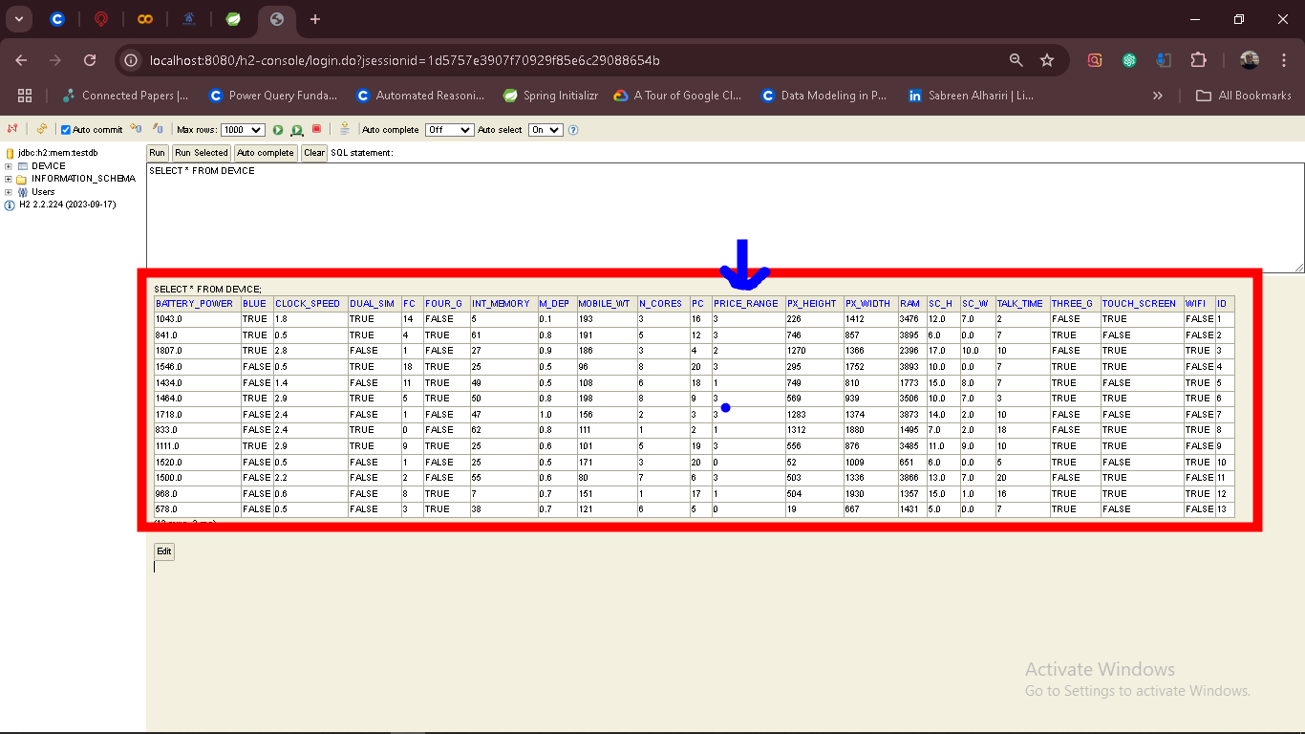

# APIS TEST

<http://localhost:5000/prediction>:

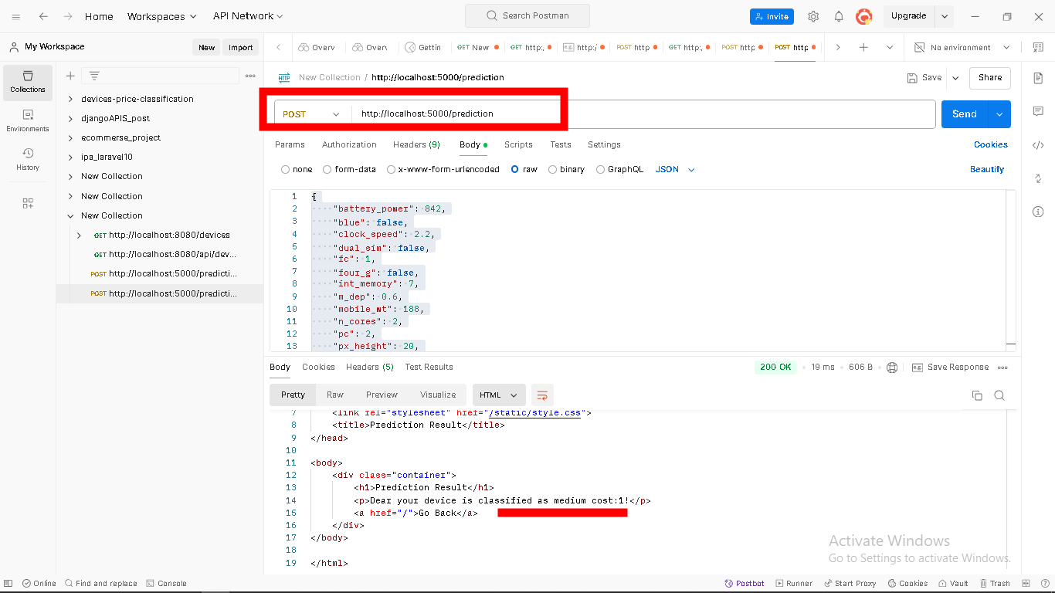

<http://localhost:8080/api/devices/predict/1>:

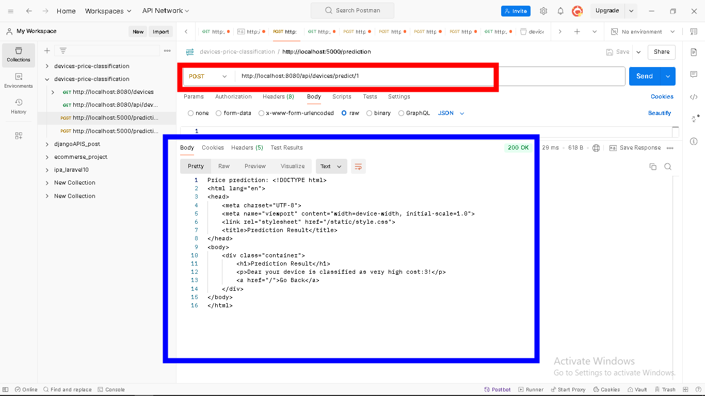

[http://localhost:8080/api/devices/{id}](http://localhost:8080/api/devices/%7bid%7d):

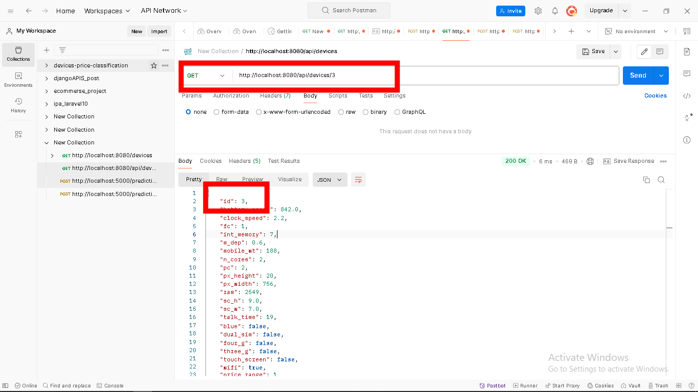

<http://localhost:8080/api/devices>:

